Paul and Elaine Kintner Baptist Mid-Missions
8 Matthew Street, Sebring, FL 33870 PO Box 308011
e-mail: pwkintner@gmail.com October 2019 Cleveland, OH 44103
“But if we walk in the light, as He is in the light, we have fellowship one with another,
and the blood of Jesus Christ his son cleanseth us from all sin.” I Juan 1:7

Dear praying friends,

As mentioned in our last letter, Elaine was scheduled for an appointment with a surgeon on September 27th. We were delighted to receive a call from his office, informing us that he was adding a couple Saturdays to his schedule to make up for the days lost during the Hurricane Dorian alarm, and would we be able to come to Orlando for appointment September 14th. Of course we complied and met with the surgeon that day. He was very thorough, and a few days later scheduled the surgery for October 10th. He will doing a minimal invasive procedure called a “spinal decompression with i/OFlex”. This should relieve the nerve pain she has suffered for a long time. We count on the prayers of many, and the Lord’s healing in this process.

After another busy month of production and preparation of large orders of materials of EBI for Latin America, the months of October and November will be filled with conferences in several countries and the northeastern United States, in which personnel will be participating. Biblical Counseling conferences are drawing large numbers of church leaders throughout Latin America, and our new EBI materials are especially valuable to this ministry. EBI produces 24 mini-books on counseling themes, plus a major text, “Christ-centered Biblical Counseling.” We have prepared a packet of 4 ,mini-books to be given to over 600 participants already registered in a conference in Mexico in November, where they will have the other materials available for purchase. The foto shows us shrink-wrapping the packets.
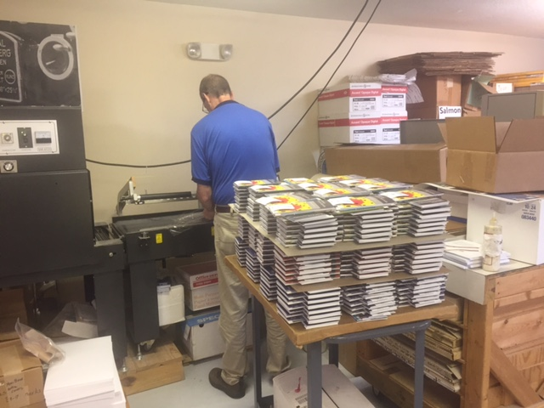
Pray Praise
Elaine’s surgery God’s protection
EBI trips and conferences God’s provision
Laborers for the harvest God’s promises
Classes in jail and prison every day

In His service,

Paul and Elaine Kintner

