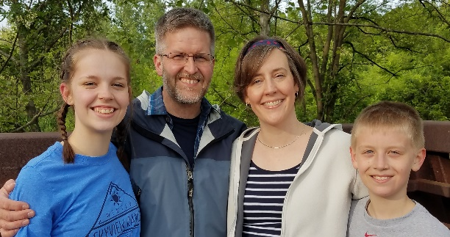
  - Faith Baptist Community Church & Center – July, 2019
2355 East 55th Street – Cleveland, Ohio 44104
216.881.8816 – www.freehope.org
1012 Plymouth Drive – Grafton, Ohio 44044
440.926.2764 – michaelandsherri@earthlink.net

Greetings from Inner-city Cleveland, July 16, 2019
Last Saturday (the 13th), we held our annual Fun Day. It is organized each year by Jackie Hopkins (our children’s ministry coordinator). It is a very active day with many children, parents, staff, and volunteers in and out of the building for various activities throughout the two-and-a-half hours it lasts. It takes a great deal of energy and coordination to accomplish such an event. It can be discouraging to end the day having planted many seeds of the gospel, but to see no actual decisions made for Christ. Such was not the case this year! After Jackie finished her lesson on sin and salvation, one boy (Kaiyne—pronounced “Cain”—was his name), said he knew God. Jackie asked him if he knew where he would go if he died. He said “no.” Jackie asked him if he would like to know, to which he said “yes.” Jackie then had opportunity to lead him to the Lord! What an encouragement and blessing. I shared that with our church congregation on Sunday and let them know that all who helped that day (we had a record number of church members/attenders who helped out), shared in the “harvest” of that young life…not that every one of them received the blessing of leading him to the Lord, but that they each had a part in the ministry that led to Kaiyne’s conviction and salvation! Pray for Kaiyne that he will grow in his new relationship with Christ!
Currently, I am preparing to teach a 12-week series of classes on Biblical parenting. We will be using a curriculum by Tony Evans entitled “Raising Kingdom Kids.” It will not focus on any specific age. Instead, it will help parents understand what the Bible says about parenting in general. The goal for this series, in part, is to be an extension of what is offered in the existing pregnancy program. As it currently stands, once the child reaches six months of age, the mom is no longer eligible to be involved in the program. Often the moms have other, older children as well. This parenting series will allow them an extension to the Learn and Earn program so they can continue their education in the parenting realm, while continuing to expose them to spiritual truth. Also, the sessions are being offered on Saturdays during our Bible Seekers club, so that the older children can participate in that ministry while the parents meet. Prayerfully, these will serve as additional connections that will encourage salvation and spiritual growth. Pray for me as I continue to prepare for this series—that it will be used to reach people for Christ. I will also be repeating the 12-week addiction class in the fall on Thursday mornings (called the Life Transformation Group). Pray for the hearts of individuals that God might direct to be a part of the new class. Five individuals successfully completed it in the spring.
Want to get involved in the ministry in Cleveland for a day? On Monday and Tuesday, August 12 and 13, we will be doing an extensive amount of interior painting around the building. Recently, we received a very generous donation which will allow us to have carpet tiles installed in the entire main room and all four of the hallways. We would like to have that painting completed before the carpet is installed on Monday and Tuesday, August 19 and 20. If you can come and help both days, one day, or even part of a day, we will appreciate the help. We will even provide lunch! Call me (at 440.309.0175) if you’d like to help, so we know how to plan.
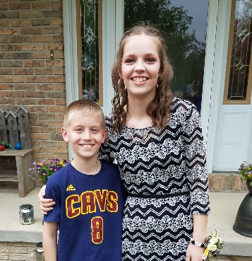
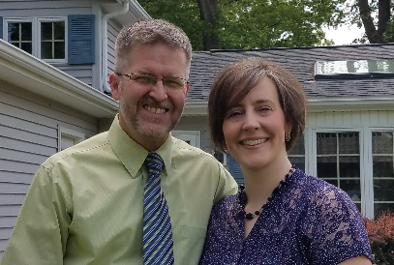
On a more personal level, thank you to all those who prayed for Emily’s surgery (she had a benign cyst removed from her sternum), for Sherri’s surgery (gall bladder removal – she is doing so much better since the surgery), and for my recovery and outcome from DBS surgery. I feel like a new person! I have more energy than ever before, normal temperature regulation, minimal symptoms and absolutely no side effects, since I remain medication-free. Also, notice the absence of a pump strap in our picture! The pump is gone! Thank you to our wonderful God for doing “abundantly above all we could ask or think” in each of our surgical situations. We hope (and pray) to not need any surgeries for a good long while!
Thanks for your encouragement, prayers, and support. We love this ministry and the people God has brought to us. Thank you for making it possible for us to be involved full-time in Cleveland.

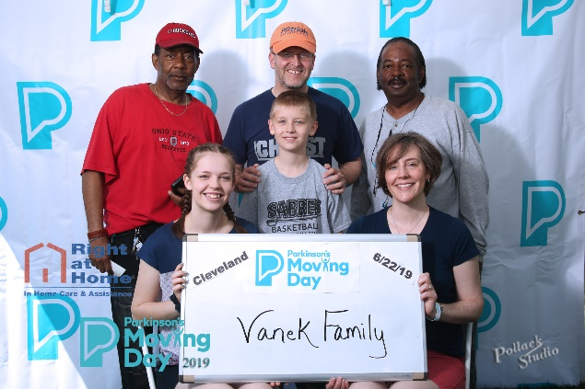
We love you in Christ,
Michael, Sherri, Emily, and Benjamin Vanek

P.S. – This year (for the first time), we were able to be involved in the Parkinson’s Foundation Moving Day walk. We even took Robert and Terry with us as members of our team. We are hoping to make this an annual event for our family and anyone else who would like to go as part of our team. I am so thankful for a family and church that are encouraging and supportive, even in an event like this!

