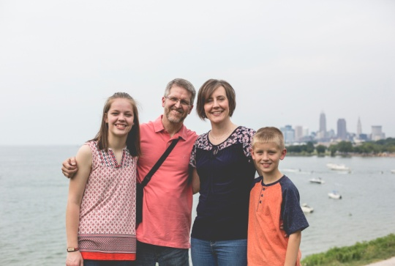
  - Faith Baptist Community Church & Center – October, 2018
2355 East 55th Street – Cleveland, Ohio 44104
216.881.8816 – www.freehope.org
1012 Plymouth Drive – Grafton, Ohio 44044
440.926.2764 – michaelandsherri@earthlink.net

Greetings from inner-city Cleveland! October 22, 2018

“…My grace is sufficient for you, for My strength is made perfect in weakness…” (from 2 Corinthians 12:9). Three times Paul asked the Lord to remove the thorn in his flesh. All three times the Lord said no; however, He didn’t leave him hanging…He gave him the promise of His all-sufficient grace…not only to endure it, but to ultimately allow the Lord’s power and glory to be demonstrated through it.

On many more than three occasions over the past 17 years, I have asked the Lord to remove the thorn of Parkinson’s Disease from my body. Thus far, the answer has been no. His grace, however, has been evident through effective medications and treatments that have allowed me to function somewhat normally, faithful prayers of brothers and sisters in Christ that have kept me going in life and ministry, and His strength that has enabled me to be strong, even in my most desperate moments of physical and emotional weakness. God is good…God is good all the time!

Over the next several months, our family is requesting that you keep us in your prayers. As I mentioned in our last prayer update, we began the process of considering deep brain stimulation (DBS) as a treatment option for my PD. At that point, we were scheduled for two days of assessments to determine my candidacy for the DBS surgery. Here is the update: one week after the assessment (8/28…my birthday!), we received the phone call informing us that the team had approved me for DBS. That was step one. Here are the next steps…

October 31: Pre-admission testing—I have nine different appointments on that day in anticipation of the surgical procedure as well as briefing on some PD research that will be conducted throughout the process.

November 9: We will meet with the neurosurgeon who will perform all three surgeries.

November 19: Surgery #1—The neurosurgeon will place an electrode into one side of the brain through a burr hole in the skull. I will be awake for a portion of this procedure to assure correct placement of the lead.

December 3: Surgery #2—This surgery will be a repeat of the first, but placing an electrode into the opposite side of the brain. The surgery and treatment are bilateral since I have symptoms on both sides.

December 11: Surgery #3—The two neurostimulators will be surgically placed in my chest directly below the collarbone (one on each side). A wire from each electrode will be relayed through my neck (behind the ear) and attached to the corresponding neurostimulator. This will be done under general anesthesia. That will complete the surgical component of the process.

January or February: Four to six weeks post-surgery, the doctor will be able to turn the system on and begin to regulate the settings. The delay is driven by the need to assure that no infection is present (if infection occurs, the whole device must be removed, the infection treated, and the process started over). Also, the brain typically swells due to having the electrodes implanted. The delay allows for the swelling to resolve.

Ongoing: Programming the DBS device is a tedious process. We have been told that it can take several months or even up to a year to achieve the optimal settings. So that will mean multiple trips to the Clinic for adjustment. The good news is that, in the end, DBS (while not a cure) is very effective at addressing some of the side effects and symptoms that are the most bothersome to me.

This will be a long process, no doubt, but I see it as another measure of the Lord’s all-sufficient grace in a life that wants nothing more than to effectively serve Him! “When I am weak, then I am strong!”

Thank you, in advance, for your prayers on our behalf. Please pray for Sherri as she goes through this with me. She is such an encouragement and support to me. Pray also for our children, Emily and Ben. They know what is happening, and while they are excited about the potential outcome, I’m sure they have their own measure of anxiety about it. They have always been supportive of and helpful to me. For that I am thankful.

We will update you as we can throughout the next several months (Sherri will post updates via Facebook)!

Serving Christ,
Michael, Sherri, Emily, and Benjamin Vanek

P.S. – I apologize for the amount of detail in this update; however, I wanted to let you know how you can pray specifically throughout this process!

